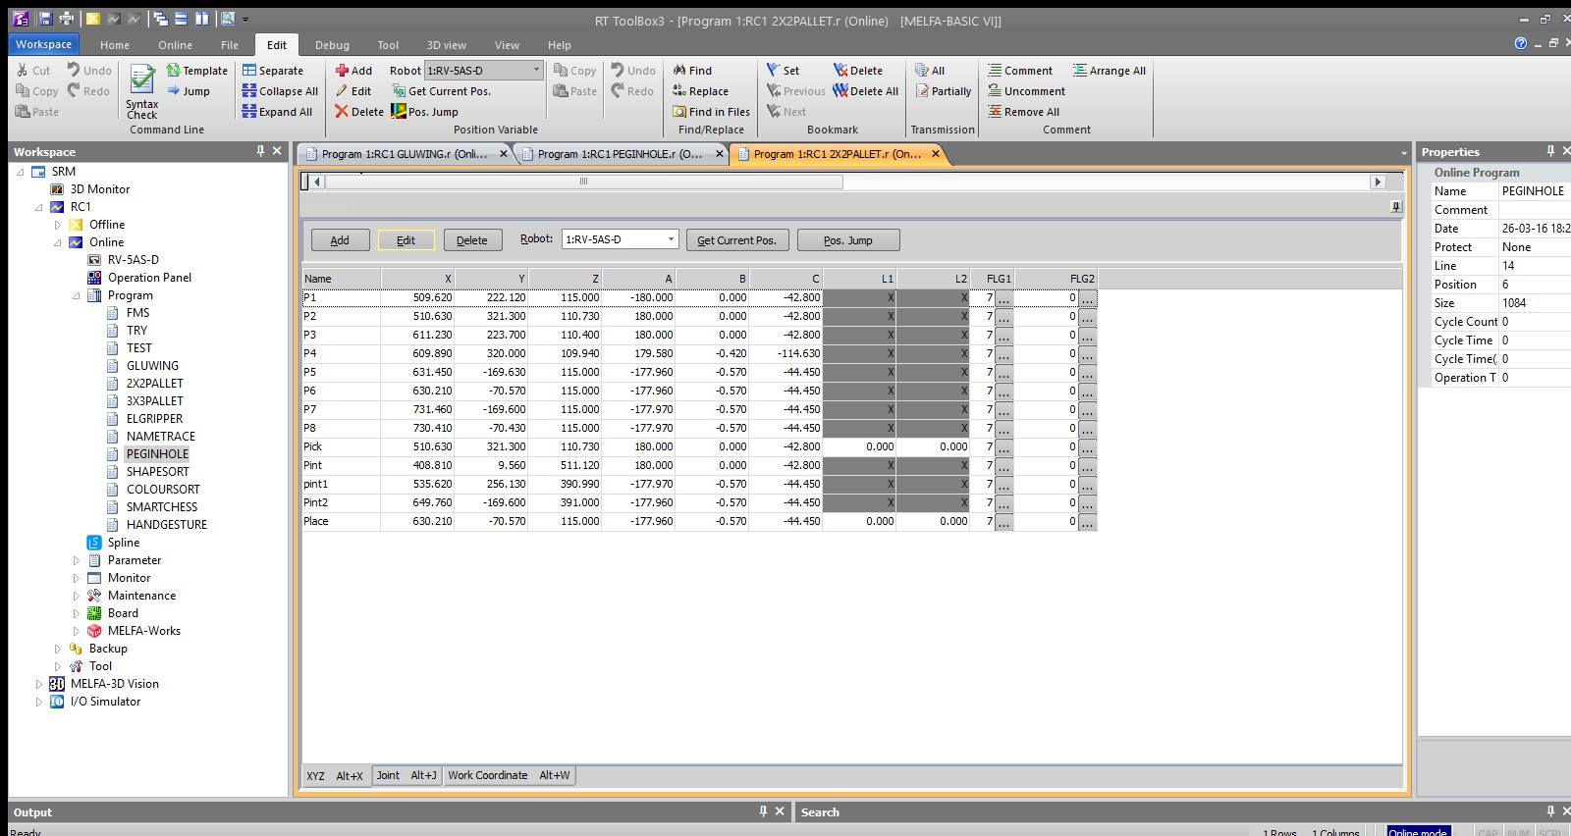
Figure 1: RT ToolBox3 position table defining 2×2 matrices (P1–P8) and intermediate routing points.
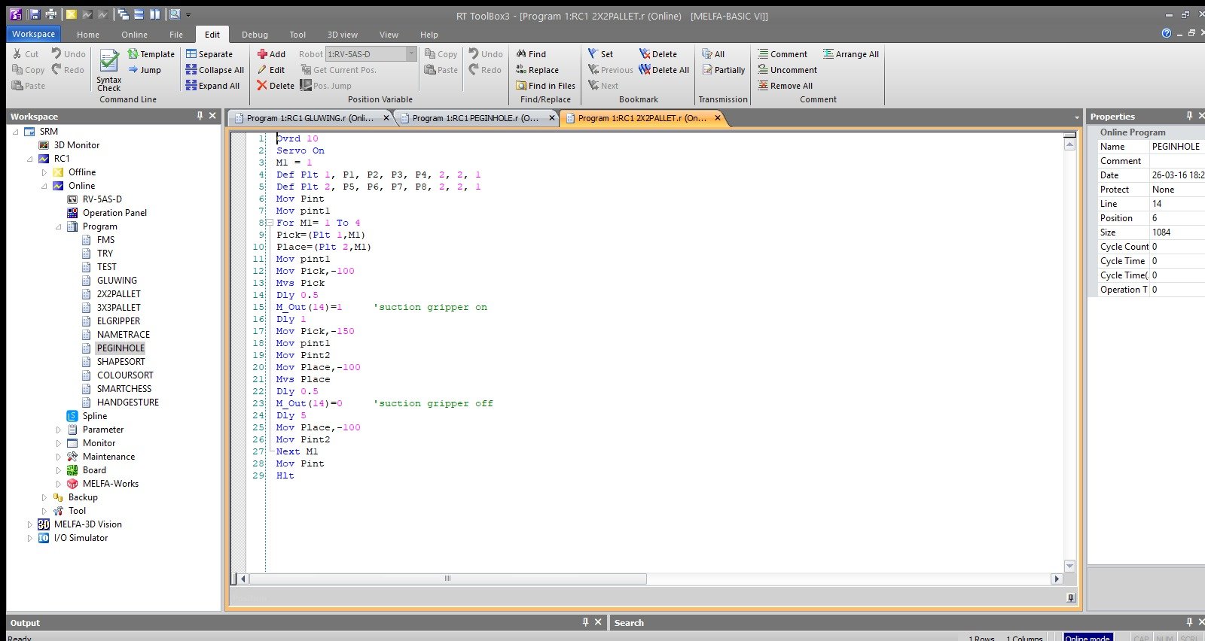
Figure 2: MELFA-BASIC VI execution sequence showing control logic and timing delays.
Expt No:  08 | PROCESS ORCHESTRATION FOR MULTI-STAGE MANIPULATION
Date:
15 / 04 /2026

- AIM:
To design and implement an integrated industrial workflow that orchestrates high-precision transfer sequences of flat circular workpieces between two distinct 2x2 matrices, utilizing deterministic state logic, vacuum-assisted End-of-Arm Tooling (EOAT), and strategically mapped clearance vectors.

- APPARATUS REQUIRED:
  - Manipulator System: Mitsubishi RV-8CRL-D 6-axis industrial robot.
  - Control Hardware: CR800-D series dedicated robot controller.
  - Software Suite: RT ToolBox3 integrated engineering environment.
  - End-of-Arm Tooling : Vacuum suction cup end-effector actuated via a pneumatic generator on Output 14.
  - Infrastructure: Two precision-cut 2x2 wooden template fixtures (Source and Destination arrays) and four flat, circular workpieces (discs).

- THEORY:
- Core Principle:
Manipulating flat, flush-seated objects requires specialized vacuum-assisted tooling rather than mechanical grippers. Orchestrating this transfer between partitioned matrices demands the strict synchronization of continuous spatial kinematics (trajectory control) with discrete binary state logic (vacuum generation and purging).
- Working Mechanism:
  - Deterministic State Logic for Vacuum Tooling: The actuation of the vacuum cup is governed by Boolean I/O mapping (M_Out(14)). Critical to this operation is the mathematical injection of temporal settling phases (Dly). Pneumatic vacuum generators experience inherent mechanical latency; delays must be enforced to allow the vacuum pressure to reach the theoretical gripping threshold (to establish a seal on the disc) before any Z-axis spatial displacement occurs.
  - Dual-Array Kinematic Orchestration: The workflow abstracts the physical wooden templates into continuous mathematical algorithms using two Def Plt commands. By isolating the source and destination grids with master intermediate routing nodes (Pint, pint1, Pint2), the sequence enforces strict vertical entry and departure vectors (e.g., Mov Pick, -100). This completely eliminates lateral sheer forces, preventing the discs from catching on the edges of the wooden templates during extraction and insertion.

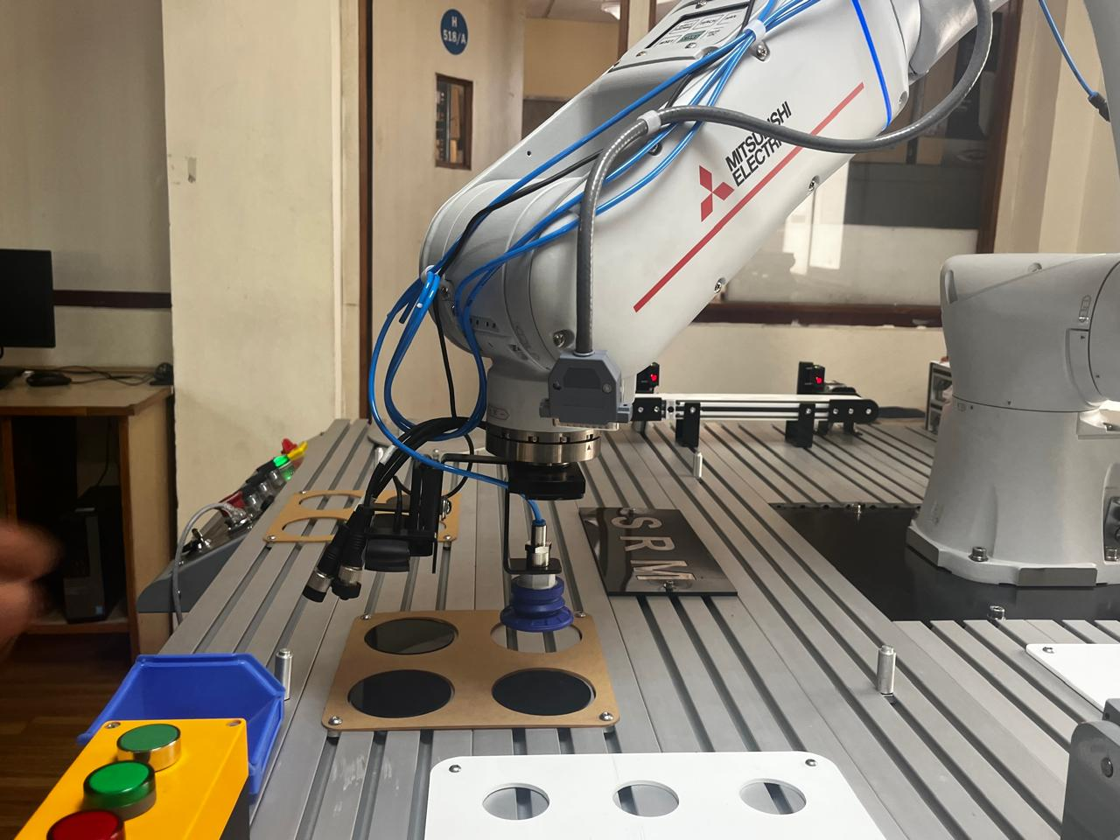
Figure 3: Gripper retrieving a circular workpiece from the source matrix.

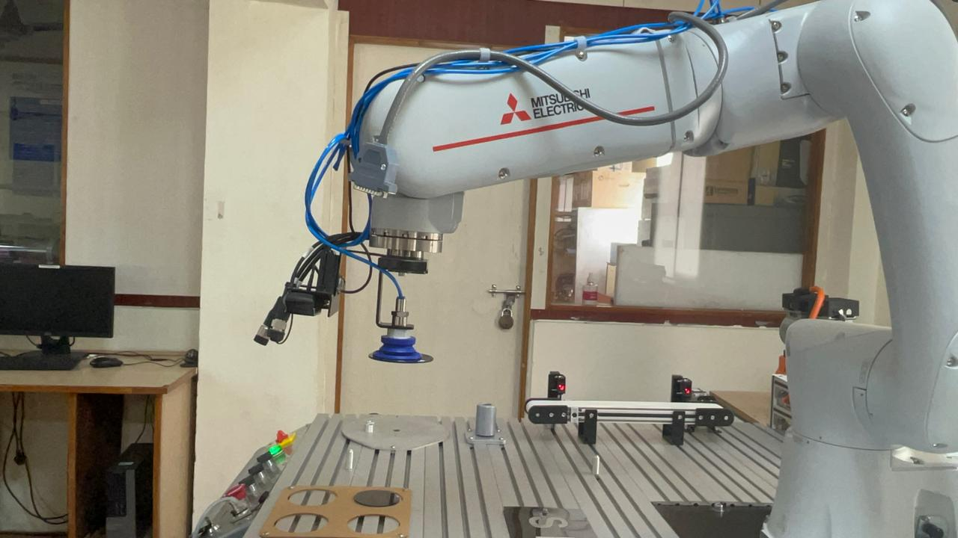
Figure 3: Manipulator transferring the workpiece through a safe intermediate path.

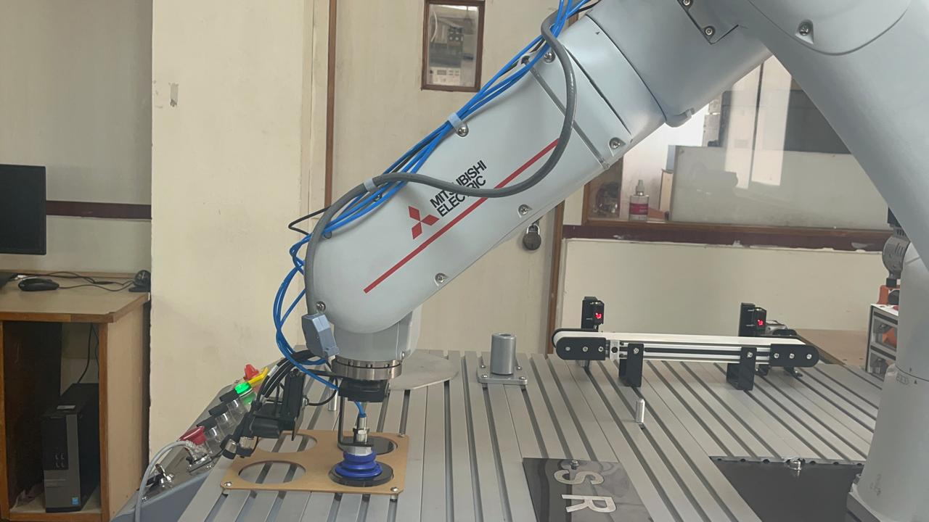
Figure 3: Vertical placement of the workpiece into the destination matrix.

- PROCEDURE:
- Setup & Connections:
Interface the vacuum generator to Output 14. Seat the four circular discs into the source wooden template. Using the teaching pendant, define the exact surface-contact center points for the 2x2 source matrix (P1 to P4) and the destination matrix (P5 to P8). Establish the intermediate safety nodes (Pint, pint1, Pint2) well above the fixture profiles.
- Algorithm & Logic:
  - Throttle the global velocity override to 10% (Ovrd 10) to prioritize spatial precision during the vacuum seal phase.
  - Define the geometry for both 2x2 matrices utilizing pattern type 1.
  - Initiate a localized loop iterating from index 1 to 4 (For M1= 1 To 4).
  - Retrieval State: Compute localized Pick and Place coordinates. Route the TCP through the source-side intermediate node (pint1). Execute a linear plunge to the disc surface.
  - Transition the state logic (M_Out(14)=1) to generate vacuum pressure. Dwell for 1.0 second to establish the seal, then retract vertically by 150mm.
  - Transfer State: Route the secured payload through the high-clearance intermediate nodes (pint1 → Pint2).
  - Placement State: Execute a vertical plunge (-100mm) into the destination template. Transition the state logic (M_Out(14)=0) to purge the vacuum. Dwell for 5.0 seconds to guarantee complete pressure equalization and payload release, then retract vertically.
  - Iterate the loop until total matrix transfer is achieved.
- Execution Steps:
  - Compile the sequence and ensure the vacuum lines are pressurized and free of mechanical kinks.
  - Perform a Step Run to verify the temporal delays (Dly 1 and Dly 5) provide adequate pneumatic latency compensation for the specific mass of the black discs.
  - Execute the sequence autonomously, ensuring the vertical offsets completely clear the wooden fixture templates during transfer.
- Observation Instructions:
Analyze the kinematic interplay between the state transition of Output 14 and the immediate subsequent Z-axis vertical lift. Observe the integrity of the vacuum seal during the rapid joint-interpolated transfer across the workspace.

- RESULT AND OBSERVATION:
The system successfully transferred circular workpieces between two 2×2 arrays. Deterministic logic and timed delays enabled reliable vacuum gripping, while strict vertical motion prevented contact with the template boundaries, as verified by faculty.

